BIG DATA GROUP PROJECTS
QUALITY OF LIFE IN CANADA
- Life Expectancy at Birth (Health Indicator)
Code:
library(tidyverse)

df <- read_csv("1310011401-eng.csv", skip = 11)
colnames(df) <- c("Age", "2017_2019", "2018_2020", "2019_2021", "2020_2022", "2021_2023")

# Convert all numeric columns
df <- df %>% mutate(across(starts_with("20"), as.numeric))
df_birth_clean <- df
df_birth_clean <- df %>% filter(Age == "0 years")
df_birth <- df_birth_clean %>%
filter(Age == "0 years")
df_long <- df_birth %>%
pivot_longer(
cols = starts_with("20"),
names_to = "Period",
values_to = "LifeExpectancy"
) %>%
mutate(
Period = recode(
Period,
"2017_2019" = "2017–2019",
"2018_2020" = "2018–2020",
"2019_2021" = "2019–2021",
"2020_2022" = "2020–2022",
"2021_2023" = "2021–2023"
),
Period = factor(
Period,
levels = c("2017–2019","2018–2020","2019–2021","2020–2022","2021–2023")
)
)
ggplot(df_long, aes(x = Period, y = LifeExpectancy, group = 1)) +
geom_line(aes(color = LifeExpectancy), linewidth = 2) +
scale_color_gradient(low = "#56B1F7", high = "#132B43") +
geom_point(size = 4, color = "black") +
geom_text(
aes(label = sprintf("%.2f", LifeExpectancy)),
vjust = -1,
size = 4
) +
labs(
title = "Life Expectancy at Birth in Canada",
subtitle = "Three-year averages showing modern gradient trend",
x = "Period",
y = "Life Expectancy (Years)",
color = "Life Exp"
) +
theme_minimal(base_size = 15) +
theme(
plot.title = element_text(size = 18, face = "bold", hjust = 0.5),
plot.subtitle = element_text(size = 12, hjust = 0.5),
axis.text.x = element_text(angle = 25, hjust = 1)
)

Output:
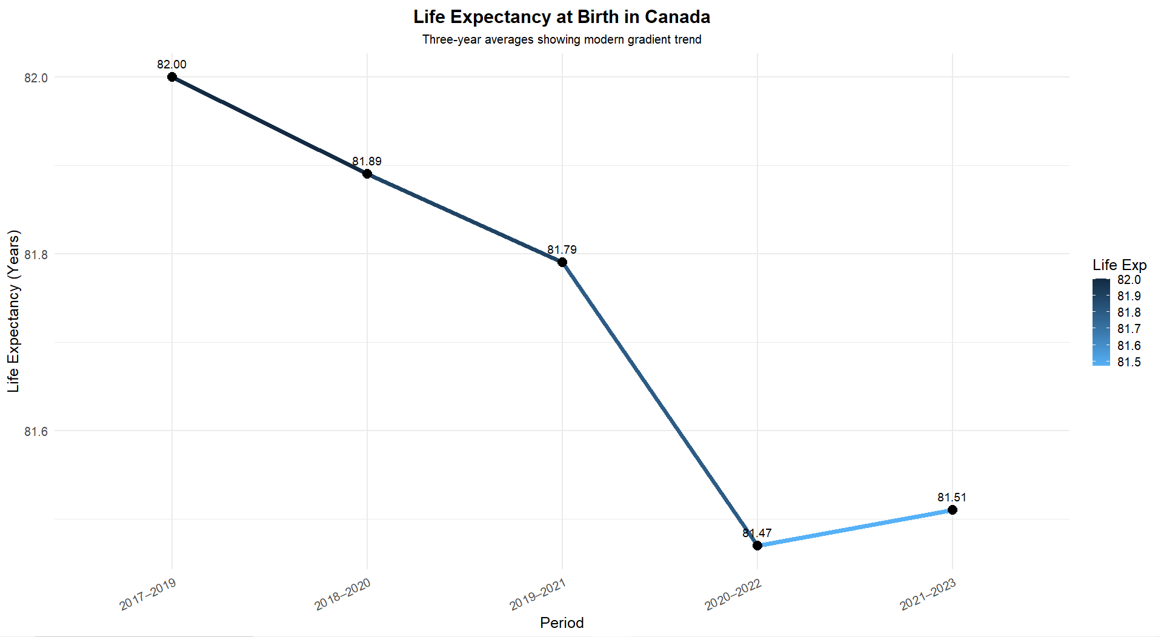
- Median After Tax Income (Prosperity Indicator)
Code:
library(tidyverse)
library(scales)

canada <- read_csv("MedianAfterTax.csv", show_col_types = FALSE)

canada_clean <- canada %>%
select(REF_DATE, VALUE)

ggplot(canada_clean, aes(x = REF_DATE, y = VALUE)) +

geom_ribbon(aes(ymin = min(VALUE), ymax = VALUE),
fill = "#e6f0ff", alpha = 0.35) +

geom_line(color = "#1a73e8", linewidth = 1.4) +
geom_point(color = "#1a73e8", size = 3) +

geom_text(aes(label = comma(VALUE)),
vjust = -1.2, size = 3.8, fontface = "plain") +

geom_point(data = subset(canada_clean, REF_DATE == 2020),
aes(x = REF_DATE, y = VALUE),
color = "red", size = 4) +

annotate("text", x = 2020,
y = max(canada_clean$VALUE) + 2500,
label = "2020 COVID-19 Spike",
color = "red", fontface = "bold", size = 4.4) +

labs(
title = "Median After-Tax Income in Canada",
subtitle = "A Prosperity Indicator in the Quality of Life Framework",
x = "Year",
y = "Income ($)"
) +
scale_y_continuous(labels = scales::comma) +
theme_minimal(base_size = 15) +
theme(
plot.title = element_text(face = "bold", size = 20),
plot.subtitle = element_text(size = 12, color = "gray40"),
axis.title = element_text(face = "bold"),
panel.grid.minor = element_blank(),
plot.margin = margin(10, 15, 10, 15)
)

Output:
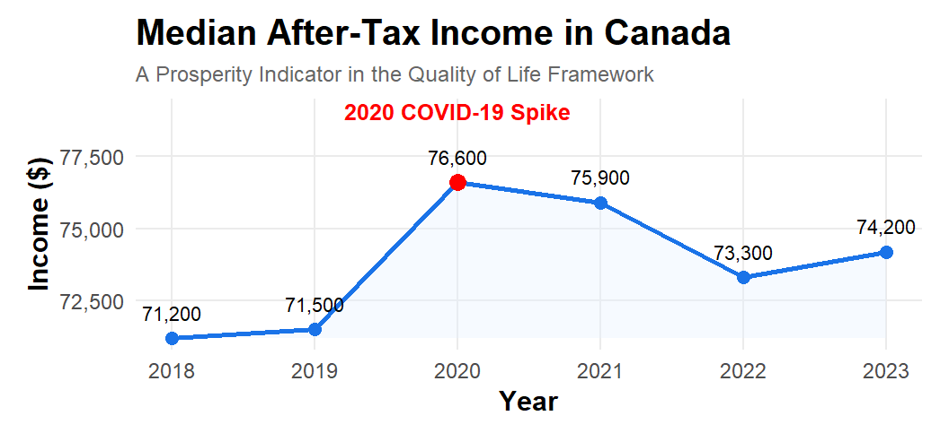

- Confidence in Federal Parliament (Governance Indicator)
Code:
library(ggplot2)
library(dplyr)

gov_data <- data.frame(
Period = c("2022-Q2", "2022-Q4", "2023-Q2", "2023-Q4", "2024-Q3", "2024-Q4"),
Trust = c(33.9, 32.4, 28.0, 28.1, 29.6, 28.3)
)

lowest_row <- gov_data %>% filter(Trust == min(Trust))

ggplot(gov_data, aes(x = Period, y = Trust, group = 1)) +

# Clean shading using annotate instead of geom_rect
annotate("rect",
xmin = 2.5, xmax = 3.5, # Covers the 2023-Q2 area cleanly
ymin = -Inf, ymax = Inf,
fill = "gray90", alpha = 0.5) +

# Main line
geom_line(color = "#005DAA", linewidth = 1.8) +

# Points
geom_point(color = "#002C5F", size = 4) +

# Labels on top of all points
geom_text(aes(label = Trust),
vjust = -0.7, size = 4, color = "#002C5F") +

# Highlight lowest point
geom_point(data = lowest_row, aes(x = Period, y = Trust),
color = "#CC0000", size = 5) +

# Label BELOW the lowest point
geom_text(data = lowest_row,
aes(label = paste0("Lowest Confidence: ", Trust, "%")),
vjust = 2.2, # moves BELOW the point
color = "#CC0000", size = 4.4, fontface = "bold") +

# Titles
labs(
title = "Confidence in the Federal Parliament in Canada",
subtitle = "Proportion of adults reporting 'high confidence' (score 4–5)\nA Good Governance Indicator in the Quality of Life Framework",
x = "Period",
y = "High Confidence (%)",
caption = "Source: Statistics Canada, Canadian Social Survey (2022–2024)"
) +

# Adjusted y-axis so line looks natural again
scale_y_continuous(limits = c(25, 36), breaks = seq(26, 36, 2)) +

# Clean theme
theme_minimal(base_size = 16) +
theme(
plot.title = element_text(size = 22, face = "bold"),
plot.subtitle = element_text(size = 14),
axis.text.x = element_text(angle = 25, hjust = 1),
panel.grid.minor = element_blank(),
plot.caption = element_text(size = 10)
)

ggsave("good_governance_final.png", width = 12, height = 7, dpi = 300)

Output:
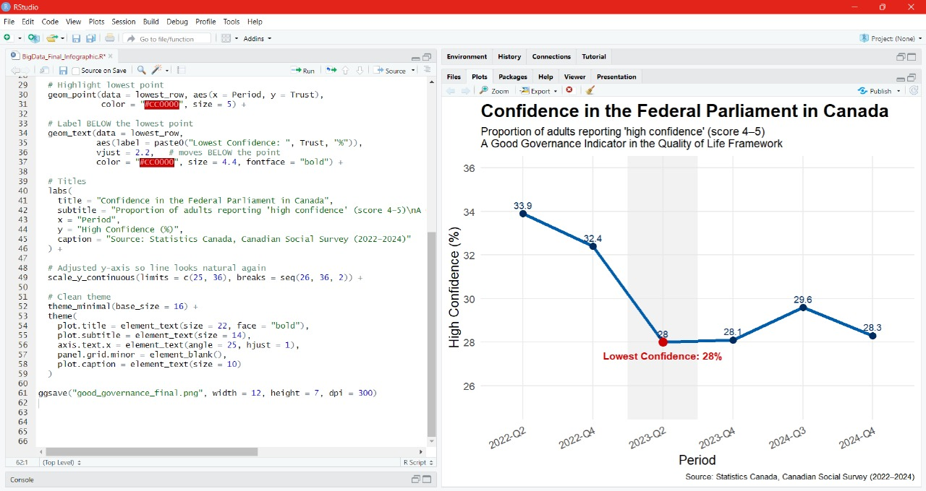
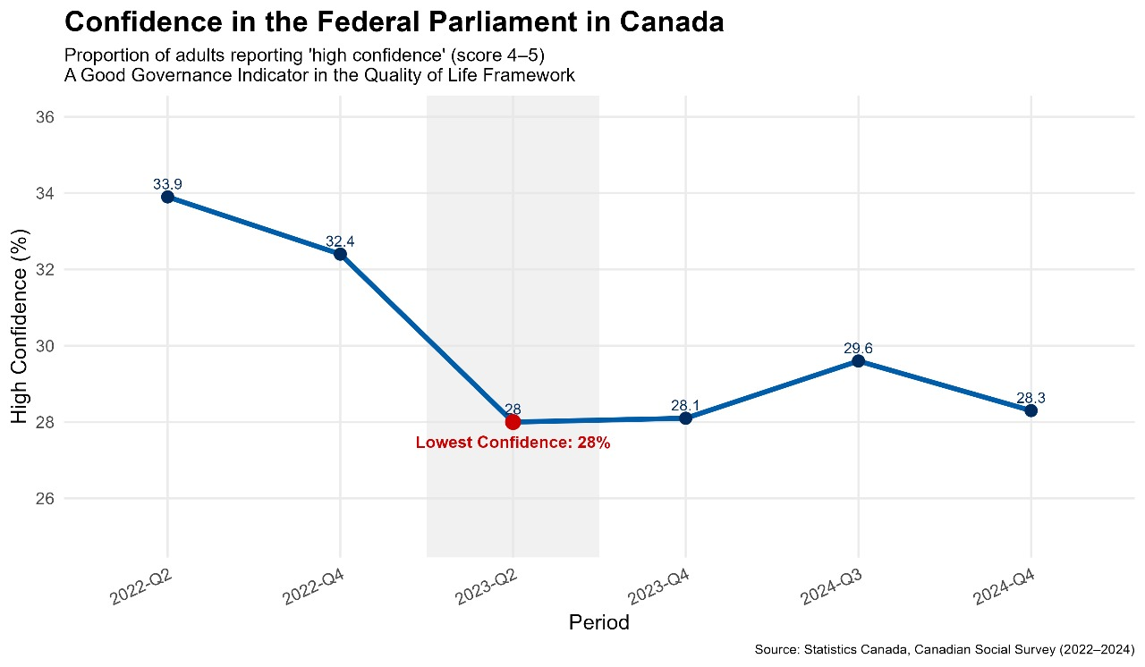

- Sense of Belonging to Local Community (Society Indicator)
Code:
install.packages("cansim")
install.packages("tidyverse")

library(cansim)
library(tidyverse)

table_id <- "45-10-0052-01"
society_data <- get_cansim(table_id)

INDICATOR_COLUMN_NAME <- "Indicators"
FILTER_VALUE_PATTERN <- "Very strong or somewhat strong sense of belonging"
GEO_FILTER <- "Canada (excluding territories)"
UOM_FILTER <- "Percent"

filtered_data <- society_data %>%
mutate(
Category_Clean = str_trim(as.character(!!sym(INDICATOR_COLUMN_NAME))),

Date = as.Date(paste0(REF_DATE, "-01"), format = "%Y-%m-%d"),
Percentage = as.numeric(VALUE)
) %>%
filter(
str_detect(Category_Clean, FILTER_VALUE_PATTERN),
GEO == GEO_FILTER,
UOM == UOM_FILTER,
!is.na(Percentage)
) %>%
select(Date, Percentage)

print(head(filtered_data))

mean_percentage <- mean(filtered_data$Percentage)

society_plot <- filtered_data %>%
ggplot(aes(x = Date, y = Percentage)) +

geom_line(color = "gray60", linewidth = 0.5) +
geom_point(color = "gray60", size = 2) +

geom_smooth(method = "loess", se = FALSE, color = "#0072B2", linewidth = 1.5) +

geom_hline(yintercept = mean_percentage,
linetype = "dashed", color = "darkred") +

annotate("text",
x = min(filtered_data$Date) + 50,
y = mean_percentage + 0.5,
label = paste("Average:", round(mean_percentage, 1), "%"),
color = "darkred", size = 4, hjust = 0) +

labs(
title = "Trend in Sense of Belonging to Local Community in Canada (Excl. Territories)",
subtitle = "Smoothed Trend and Actual Quarterly Data Points", # Updated subtitle
caption = "Source: Statistics Canada Table 45-10-0052-01 (Quality of Life Hub)",
y = "Percentage (%)",
x = "Reference Date"
) +

theme_minimal() +
theme(
plot.title = element_text(face = "bold", size = 16, hjust = 0.5),
plot.subtitle = element_text(size = 12, hjust = 0.5),
axis.title.x = element_text(face = "bold"),
axis.title.y = element_text(face = "bold"),
panel.grid.minor = element_blank()
)

print(society_plot)

ggsave("society_belonging_graph_smoothed.png", plot = society_plot, width = 10, height = 6, units = "in", dpi = 300)

Output:
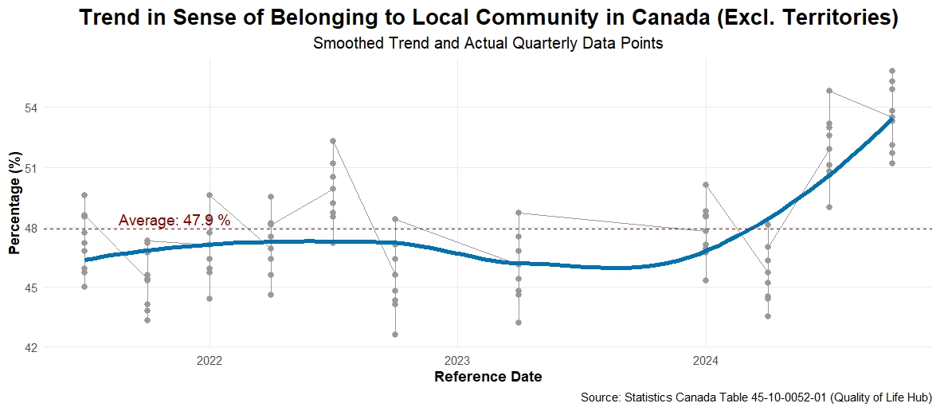

- Green House Gas Emissions (Environment Indicator)
Code:
library(ggplot2)

ghg <- data.frame(
year = c(2016, 2017, 2018, 2019, 2020, 2021, 2022, 2023),
emissions = c(725, 738, 747, 747, 682, 694, 700, 694)
)

# Create segment-level variables
ghg$next_year <- c(ghg$year[-1], NA)
ghg$next_emission <- c(ghg$emissions[-1], NA)

# Green by default, red when emissions drop
ghg$segment_color <- ifelse(ghg$next_emission < ghg$emissions,
"red", "#1B5E20")

ggplot(ghg, aes(x = year, y = emissions)) +
# coloured line segments
geom_segment(
aes(xend = next_year,
yend = next_emission,
colour = segment_color),
linewidth = 1.6
) +
geom_point(size = 3) +
geom_text(
aes(label = emissions),
vjust = ifelse(ghg$year %in% c(2018, 2019), 1.8, -0.8),
hjust = ifelse(ghg$year == 2020, 1.3,
ifelse(ghg$year == 2019, -0.4, 0.5)),
size = 5
) +
scale_x_continuous(breaks = ghg$year) +
scale_colour_identity() + # <- tell ggplot to use colors as-is
labs(
title = "Canada’s Greenhouse Gas Emissions ",
subtitle = "An Environment Indicator in the Quality of Life Framework",
x = "Year",
y = "Megatonnes CO2 Equivalent"
) +
theme_minimal(base_size = 20) +
theme(
plot.title = element_text(face = "bold", size = 22, hjust = 0.5),
plot.subtitle = element_text(size = 14, hjust = 0.5)
)

Output:
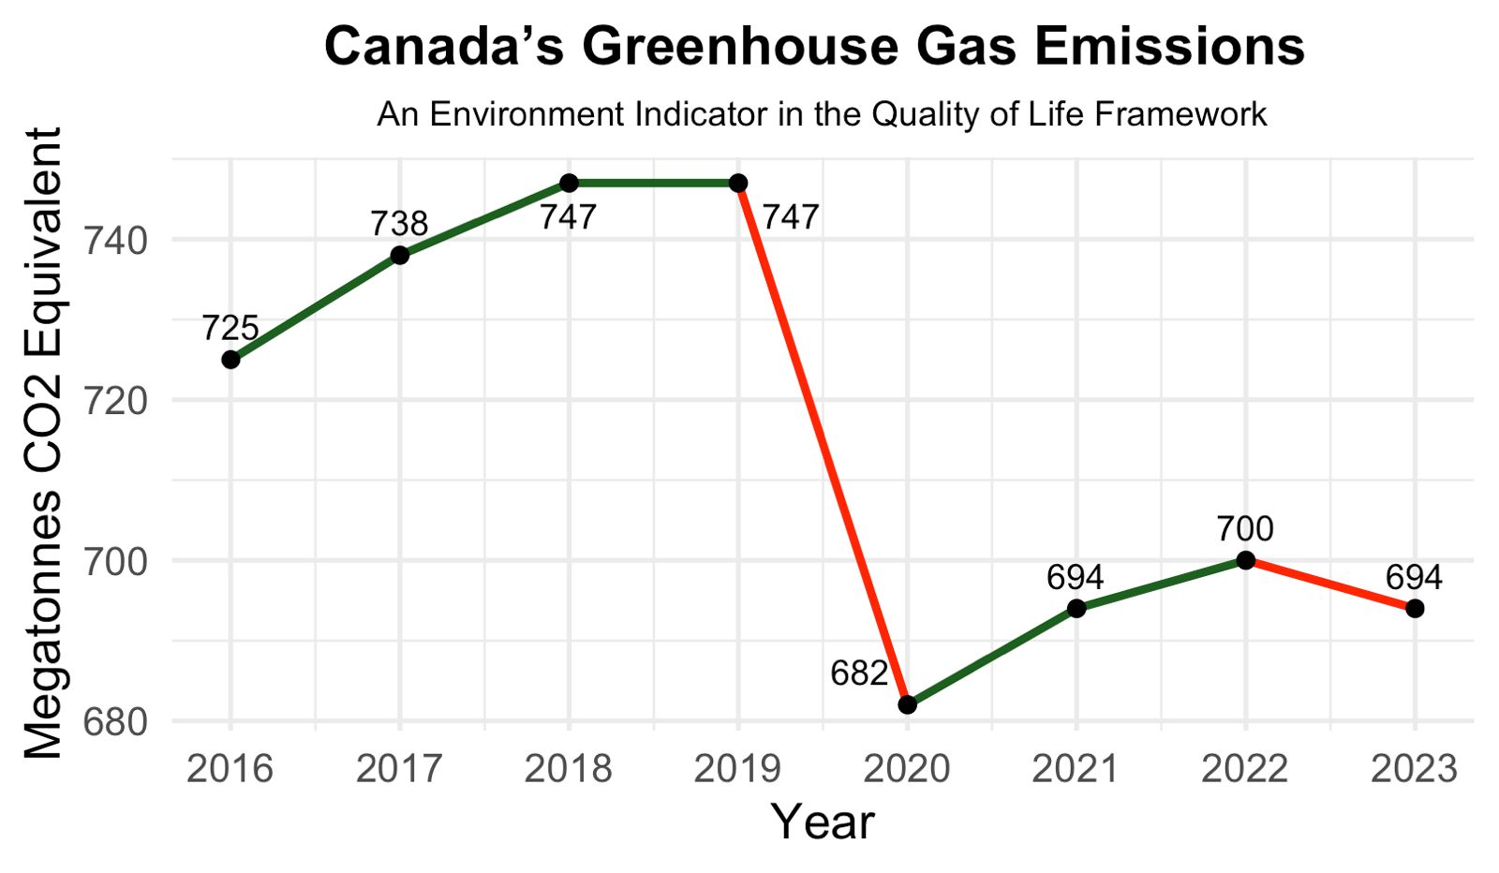

Video Presentation Link:
https://www.canva.com/design/DAG6s7kBo-Y/5i9xEBQN4-5aiRSRwfLhGw/edit?utm_content=DAG6s7kBo-Y&utm_campaign=designshare&utm_medium=link2&utm_source=sharebutton

